PRUEBAS DE CAJA BLANCA

JJACK INVENTOPRIES

SENA CEET

BOGOTÁ D.C.

2019

PRUEBAS DE CAJA BLANCA (CAMINO BASICO)

2

1

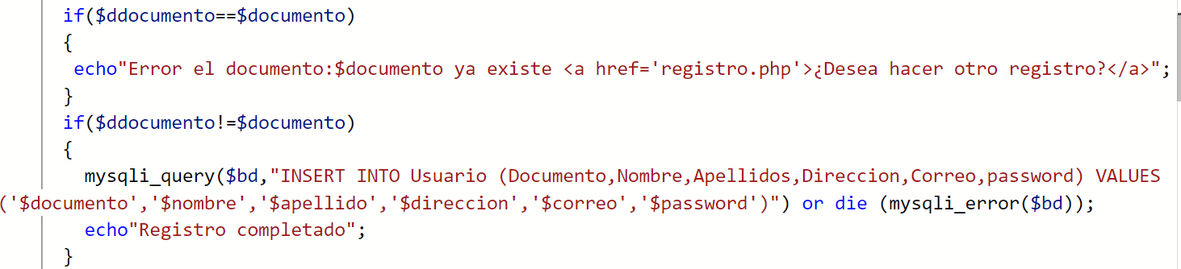

6

5

4

3

Inicio

Fin

V

6

F

5

V

F

F

4

V

F

3

V

2

1

|  |  |  |  |
| --- | --- | --- | --- |
| $ddocumento | $documento | Valor esperado | Valor sistema |
| F | F | F | F |
| F | V | F | F |
| V | F | F | V |
| V | V | V | V |

Inicio

Fin

V

6

F

5

V

F

V

4

V

V

3

F

2

1

|  |  |  |  |
| --- | --- | --- | --- |
| $ddocumento | $documento | Valor esperado | Valor sistema |
| F | F | F | F |
| F | V | F | V |
| V | F | F | F |
| V | V | V | V |

Inicio

Fin

V

F

5

V

F

F

4

V

V

3

F

2

1

6

|  |  |  |  |
| --- | --- | --- | --- |
| $ddocumento | $documento | Valor esperado | Valor sistema |
| F | F | F | F |
| F | V | F | F |
| V | F | F | F |
| V | V | V | V |